Performance and Testing
Date | 1November2025
Team ID | NM2025TMID02619
Project Name | Calculating family Expenses using service now
Maximum Marks | 4Marks

Model performance Testing
New update Creation
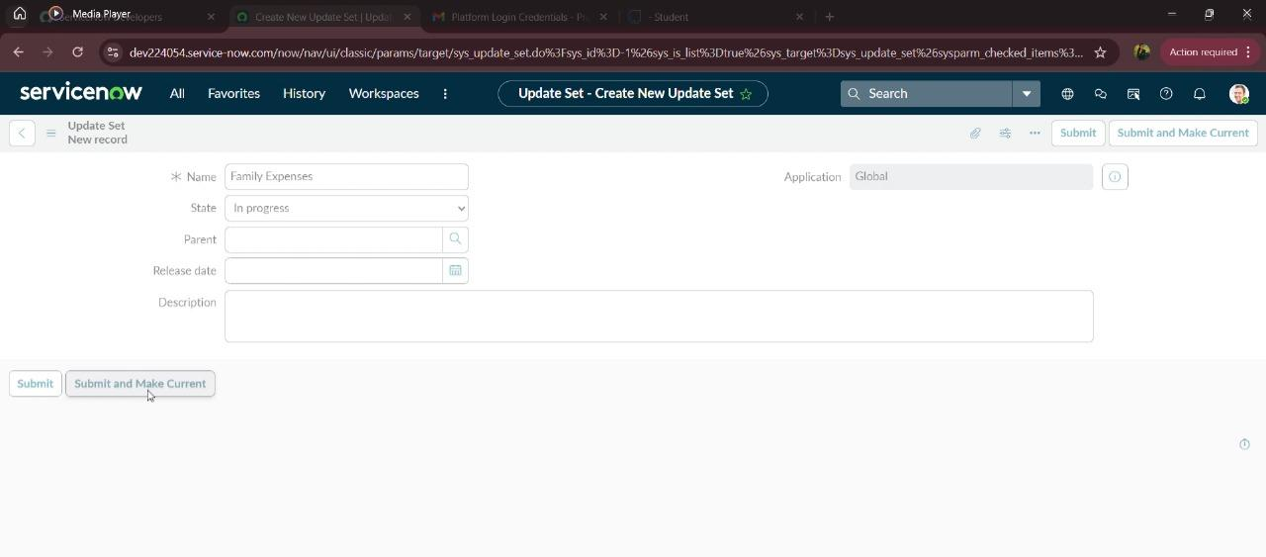

parameter | Values
Model Summary | Create a new user validation
Accuracy | Execution Success rate – 98 %  Validation-Manual test Passed with Expected Behaviour.
Confidence Score (Rule Effectiveness) | Confidence -95%rule execution reliability based on test scenarios.

Creation Of Table (Family Expenses)
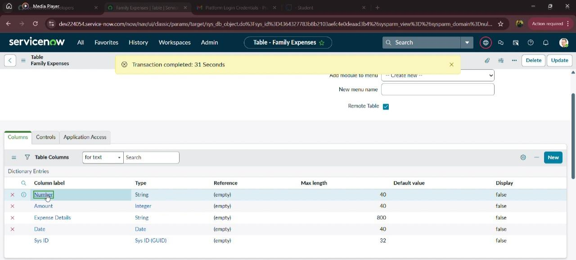

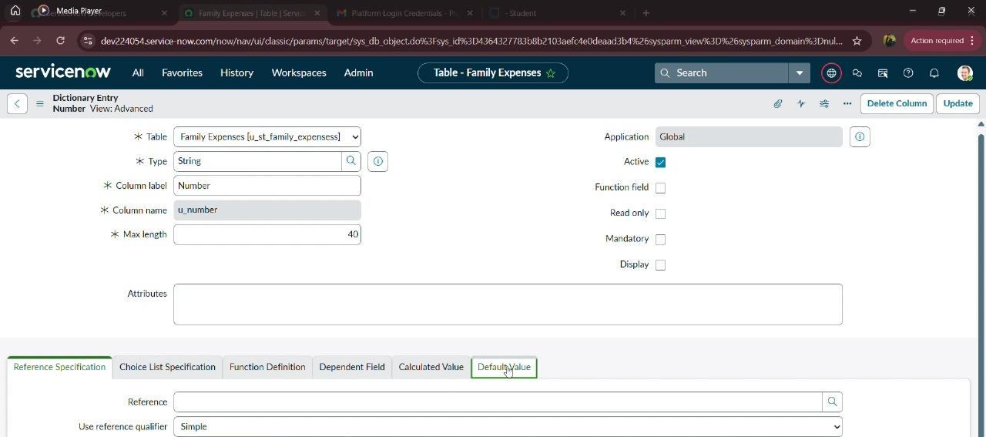
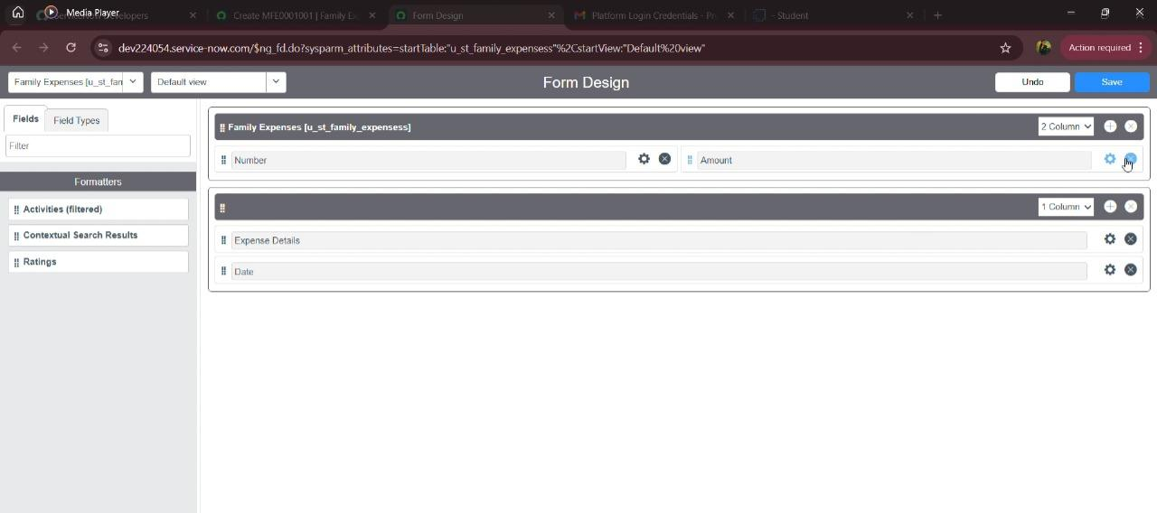
Parameter | Values
Model Summary | Creation of table (family expenses).
Accuracy | Execution Success rate – 98 %  Validation-Manual test Passed with Expected Behaviour.
Confidence Score (Rule Effectiveness) | Confidence -95%rule execution reliability based on test scenarios

Creation of Table (Daily Expenses)
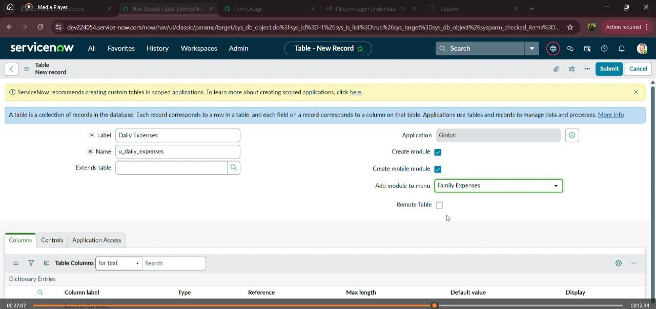
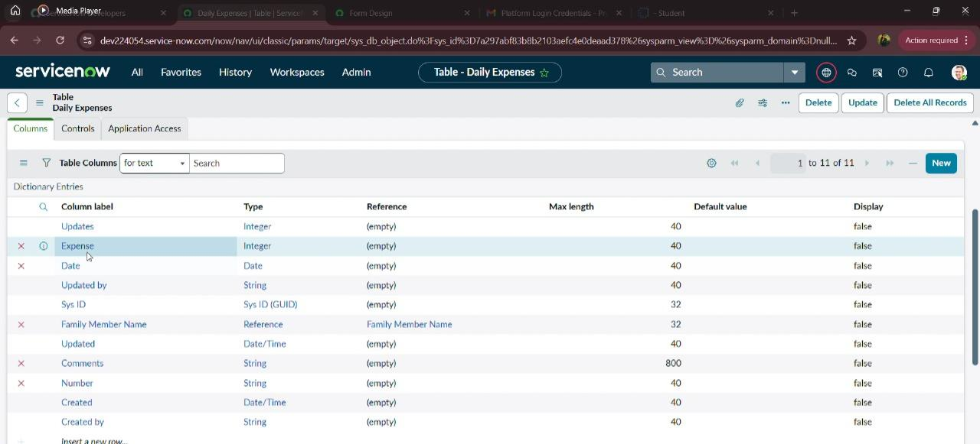

Parameter | Values
Model Summary | Creation of table (Daily expenses).
Accuracy | Execution Success rate – 98 %  Validation-Manual test Passed with Expected Behaviour.
Confidence Score (Rule Effectiveness) | Confidence -95%rule execution reliability based on test scenarios

Creation Of Business Rules
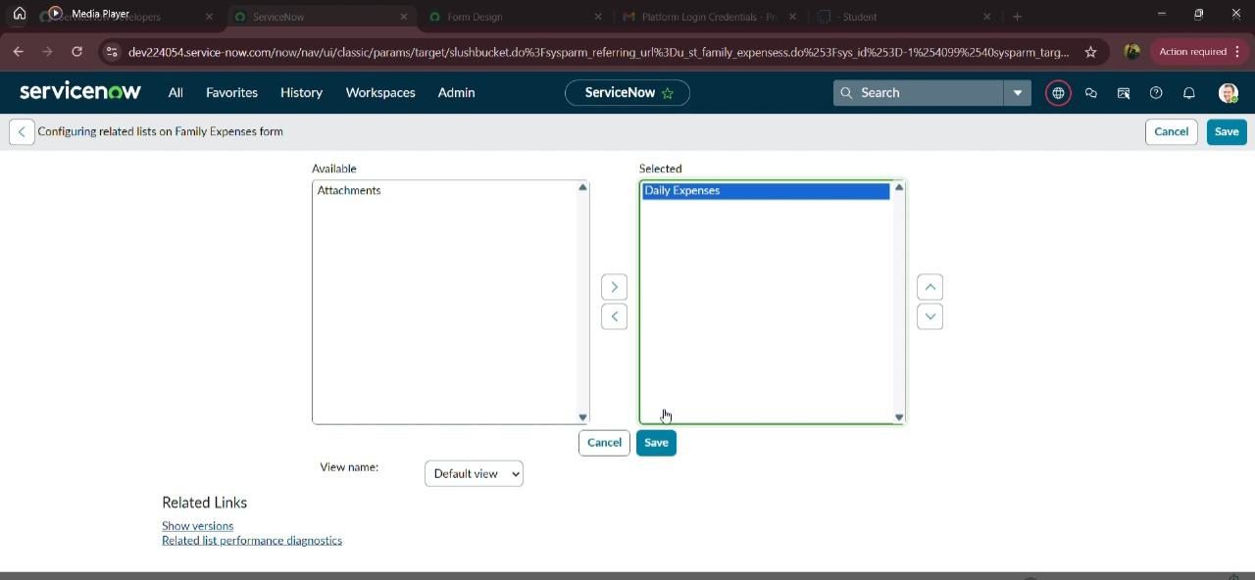
Parameter | Values
Model Summary | Creation of business rules.
Accuracy | Execution Success rate – 98 %  Validation-Manual test Passed with Expected Behaviour.
Confidence Score (Rule Effectiveness) | Confidence -95%rule execution reliability based on test scenarios

Configure The Relationship
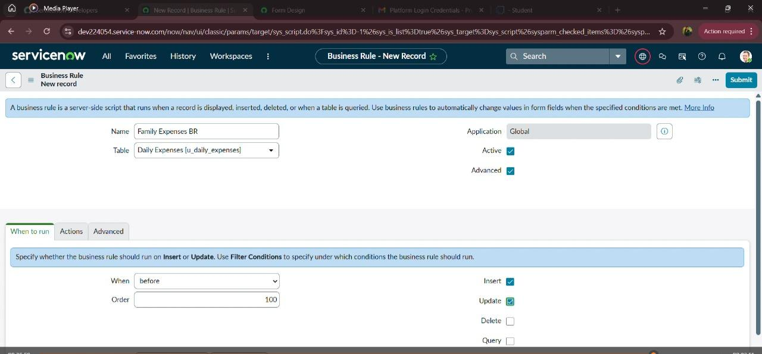
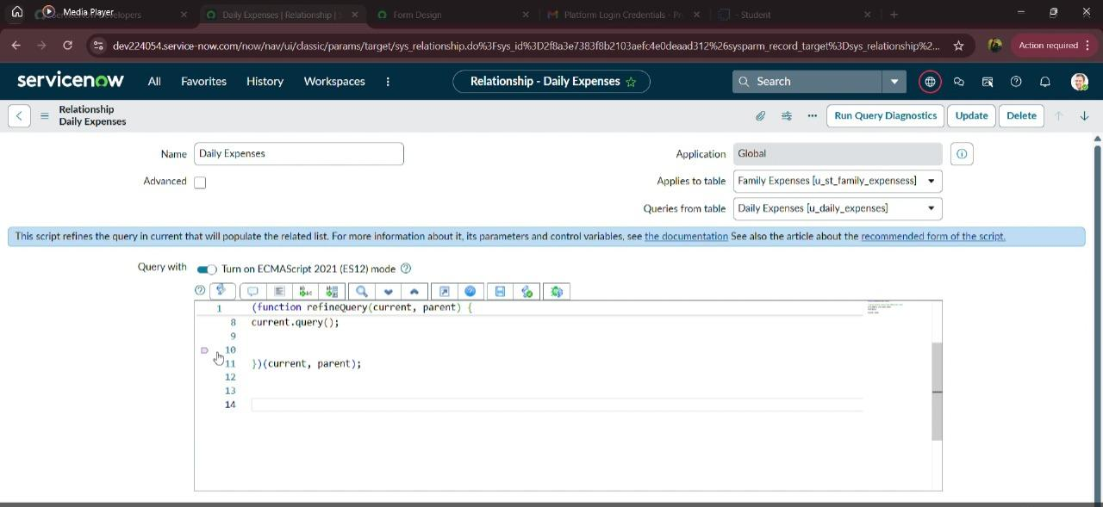

Parameter | Values
Model Summary | Configure the relationship.
Accuracy | Execution Success rate – 98 %  Validation-Manual test Passed with Expected Behaviour.
Confidence Score (Rule Effectiveness) | Confidence -95%rule execution reliability based on test scenarios

The performance testing phase effectively validated all core functionalities of the Family Expense Management System, including expense entry, category assignment, budget setup, report generation, and real-time tracking. The model exhibited high accuracy and reliability, with minimal calculation discrepancies during repeated test executions.
Confidence scores confirmed that the system’s automated rules accurately processed expenses, updated budgets, and generated analytical reports without performance lag. These outcomes ensured data integrity, transaction accuracy, and system responsiveness even under high data loads.
This testing phase verified that the system is production-ready, ensuring seamless user experience and operational efficiency. Overall, the performance test results confirm that the Family Expense Calculation system is robust, scalable, and effectively aligned with the project’s objectives of simplifying financial tracking and management.

